**The Boomerang**

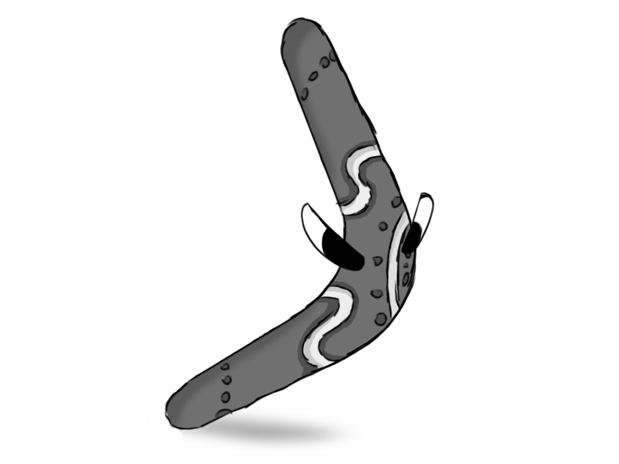

*Figure 1 - Enemy: Boomerang*

**Brief Synopsis**

The Boomerang is, as its name implies, a living boomerang that throws itself. It moves in wide arcs around the level trying to angle itself towards the player. if the boomerang collides with anything, it will take damage, and if it hits something with health it deals contact damage to it. This means, if the player were to redirect the boomerang with the staff into another enemy, they could kill both enemies at once. This would be somewhat difficult to do; however, it would provide a reward for high skilled players but also doesn’t punish weaker players heavily as they can still kill the boomerang with their usual attacks.

**Variants**

There could be variants on the boomerang that follow differently shaped paths based on their colour:

**Brown:**

* Moves in a typical arc towards circling towards the player.

**Blue**

* Moves in a wavy arc making it harder to predict its moves.

**AI**

The boomerang will usually return to the position at which it threw itself but should be able to warp its arc somewhat in order to aim at the player. The arc should also change each time it throws itself so that it will hit where the player will be.

**Animations**

The Boomerang will have three states; idle, thrown and death.

**Idle:**

* The boomerang will stand on its point upright, jumping on the spot slightly.

**Self-Throw**

* The boomerang jumps up to a horizontal position, then starts spinning.

**Death**

* If the boomerang hits something, it will land on the ground and disappear.

**Average Size**

